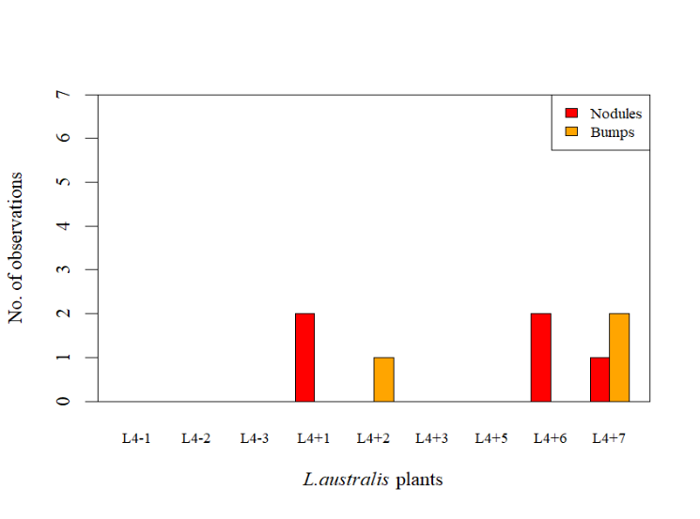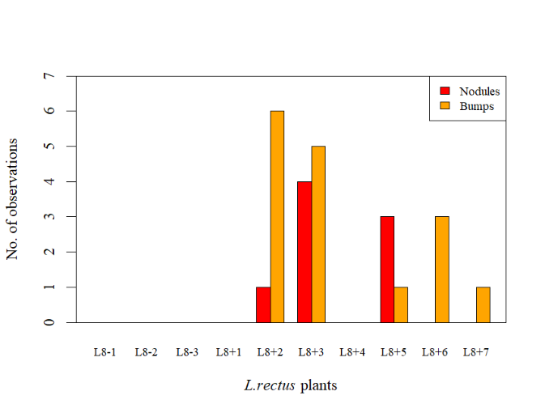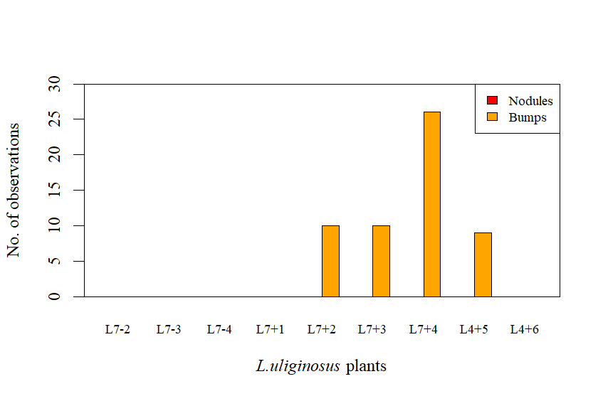

**a)**

**c)**

**b)**

**Fig 1.** Species-specific results of the Nodulation Assessment. Counts of symbiosis indicators (“Nodules” and “Bumps”) for each subject of each species. Subjects with a “-” indicate a negative control (not inoculated) while subjects with a “+” indicate that inoculation with *M. australicum* BR1-1-5xICE*Ml*Sym occurred. **a)** *L.rectus* Tas2206 **b*)*** *L. australis* ID#3 **c)** *L. uliginosus* GLOC005.

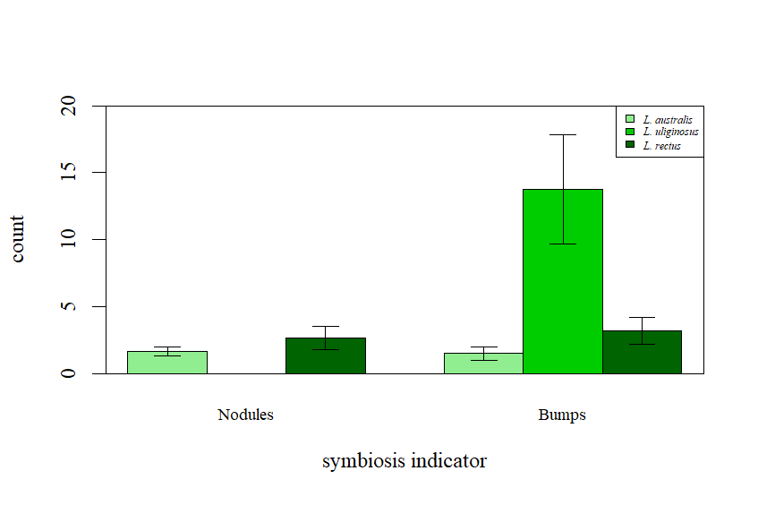

**Fig 2.** Comparison of average (±95%CI) counts of symbiosis indicators, “Nodules” and “Bumps”, organised by *Lotus* species (*L. australis* ID#3*, L. uliginosus* GLOC005, *L. rectus* Tas2206)

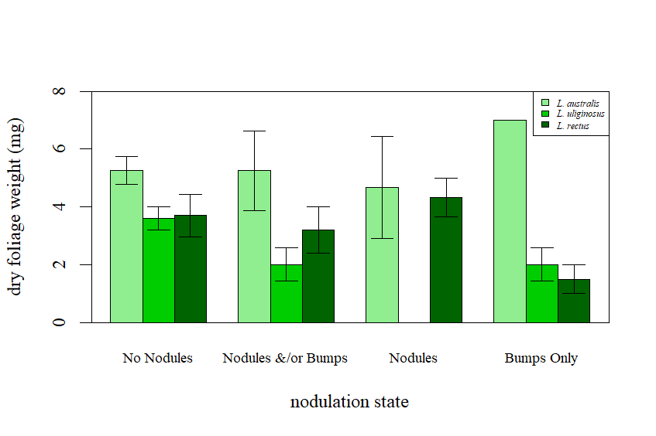

**Fig 3.** Comparison of average (±95%CI) dry foliage weight (mg) sorted by nodulation state, “No Nodules”, “Nodules and/or Bumps”, “Nodules” (includes plants that possess either nodules only, or nodules and bumps) , “Bumps Only” (excludes plants with nodules and bumps), organised by *Lotus* species (*L. australis* ID#3*, L. uliginosus* GLOC005, *L. rectus* Tas2206)